### What type of language is C?

* C is **function-oriented** (rather than object-oriented)
* C (like Java) is **statically typed**, so variables must be declared with a type and remain that type for the duration of the program’s execution
* C has **no garbage collection**: the programmer must manage all dynamically allocated memory themselves

### Hello, World!

| #include <stdio.h>  int main(int argc, char* argv[]) {  printf(“Hello world!”);  } |
| --- |

* #include <stdio.h> tells the pre-processor (a programmer that runs before the compiler) to include the stdio (standard input/output) C library when compiling this program
* stdio contains (among other things) the definition for the function printf()
* When you run a C executable, it will start execution from the main() function
* The main function takes two arguments:
  + argc: the number of arguments including the name of the executable
  + argv: an array of all of the command line arguments as strings
  + ./a.out foo 6 7
    - argc == 4
    - argv will hold a pointer to memory that looks like this:

| 0xFFFF0000 | 0xFFFF0006 | 0xFFFF000A | 0xFFFF000C | NULL |
| --- | --- | --- | --- | --- |

(an array of pointers to memory that might look something like this:)

| 0xFFFF0000   | a | . | o | u | t | \0 | | --- | --- | --- | --- | --- | --- | | 0xFFFF0006   | f | o | o | \0 | | --- | --- | --- | --- | | 0xFFFF000A   | 6 | \0 | | --- | --- | | 0xFFFF000C   | 7 | \0 | | --- | --- | |
| --- | --- | --- | --- | --- | --- | --- | --- | --- | --- | --- | --- | --- | --- | --- | --- | --- | --- |

* + - Strings are arrays of characters (8-bit numbers between 0 and 255 that represent ASCII values) that end in a null terminator (the \0 character)
* printf() will print its contents to STDOUT (standard output)
  + Strings in C are indicated by “ ” double quotes
  + Single quotes ‘ ’ are for characters

### 

### Basic Syntax

Functions and Variable Definitions

| int foo (int baz, size_t bar) {  int retval = 5;  return retval * bar + baz;  } |
| --- |

* Functions are declared in the format

**return_type** function_name(**variable_type** variable_name, …) { function_body }

* If you declare a variable inside a function, it is limited in scope to that function (you cannot access it from outside that function)
* Functions are pass by value

Loops and Conditionals

| if (a > *b) {  return bar;  } else if (a == *b) {  return foo;  } else {  return baz;  }  int i; // After C99, you can also declare in for loop  for (i = 0; i < n; i++) {  array[i] = i;  }  while (n != 42) {  n += array[i];  } |
| --- |

### 

### sizeof()

* What does sizeof() do?
  + Tells you the size in bytes of the variable type that you pass in. Characters are *always* one byte, in every system.
  + Everything else can vary in size! Do NOT rely on an integer being 4 bytes. It is true that for numbers, it goes short <= int <= long <= long long.

| In a 64-bit system with 4-byte integers…  int x; // sizeof(x) == 4  int * y; // sizeof(y) == 8  int ** z; // sizeof(z) == 8  int arr[7]; // sizeof(arr) == 28 |
| --- |

* Takeaways:
  + Pointers are always the same size, which depends on architecture
  + Calling sizeof() on an array returns the number of bytes in the whole array

### Pointers

* A pointer is **an address in memory** **where a variable lives**

| int x = 0x61c;  int y = 0x2a;  int * p = &y; // p is a pointer to y  int ** pp = &p; // pp is a pointer to p |
| --- |

* & is the address operator; putting it before a variable will give you the address where that variable is stored in memory
* * is the dereference operator; putting it before a variable will treat the variable as an address and give you what value is stored at that address in memory
* Pointers are how we get pass by reference functionality from a pass by value language
* Every programming language uses pointers that are actually addresses; C is unique in that it very directly exposes them to the programmer

Pointer Arithmetic

* You can perform addition and subtraction operations on pointers
  + Can add or subtract a number from a pointer
  + Can subtract one pointer from another
  + Do not add two pointers together!
* All addresses are byte addresses, but arithmetic doesn’t work in units of bytes but in units of sizeof(variable pointed to)

| Example: assume sizeof(int) == 4, sizeof(int *) == 8  int x = 5;  int * y = &x; // y = 0x4000  y = y + 2; // y = 0x4008, added 8  char * z = “bears!” // z = 0x2000  z = z + 2; // z = 0x2002, added 2  int ** q = &y; // q = 0x6000  q = q + 2; // q = 0x6010, added 16 |
| --- |

### Operator Precedence

* The order in which you apply operators in C depends on operator precedence
* Not something to memorize! Look at a table:

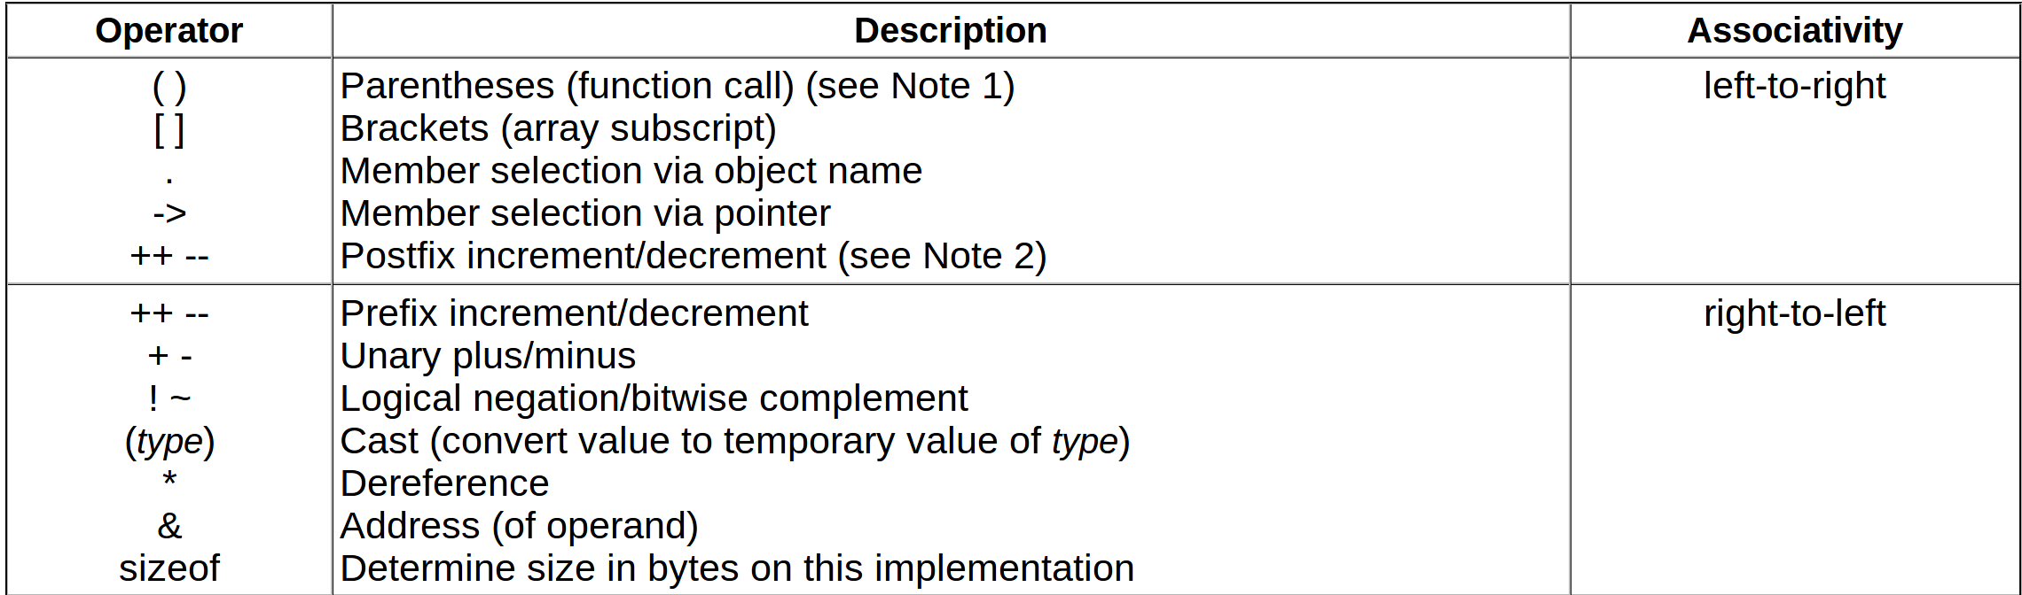

* *p++ is equivalent to *(p++)
* ++*p is equivalent to ++(*p)
* *++p is equivalent to *(++p)
* &p->next is equivalent to &(p->next)

### Structs

* A struct in C is an ordered grouping of variables
* Syntax: don’t forget the semicolon after the last bracket!

| struct foo {  int bar;  char baz;  float qux;  }; |
| --- |

* You can assume that if we have a struct foo x, x->bar will have the lowest memory address, &(x->baz) will be the next greatest, and &(x->qux) will be the highest
* When we say we’re using 32-bit word-aligned architecture, this means every variable with size >= 4 will start at an address that is a multiple of 4, and if necessary, there will be some empty space in the middle of the struct
  + For the struct above, if a float is 4 bytes, and int is 4 bytes, and a char is 1 byte, if we were using 32-bit word aligned architecture, we’d have sizeof(struct foo) == 12

### typedef

* Giving one defined type another name

| typedef uint32_t u_int32_t; // When we use u_int32_t it will refer to uint32_t  typedef uint8_t ONE_BYTE; // Now when we use ONE_BYTE it will refer to uint8_t  typedef struct node {  int value;  struct node * next;  } ll_node; // Now when we use ll_node it will refer to this struct |
| --- |

### Heap, Static, Stack & Code

**Stack:** function local variables, strings allocated as arrays (e.g. char bears[10] = “Go Bears!”)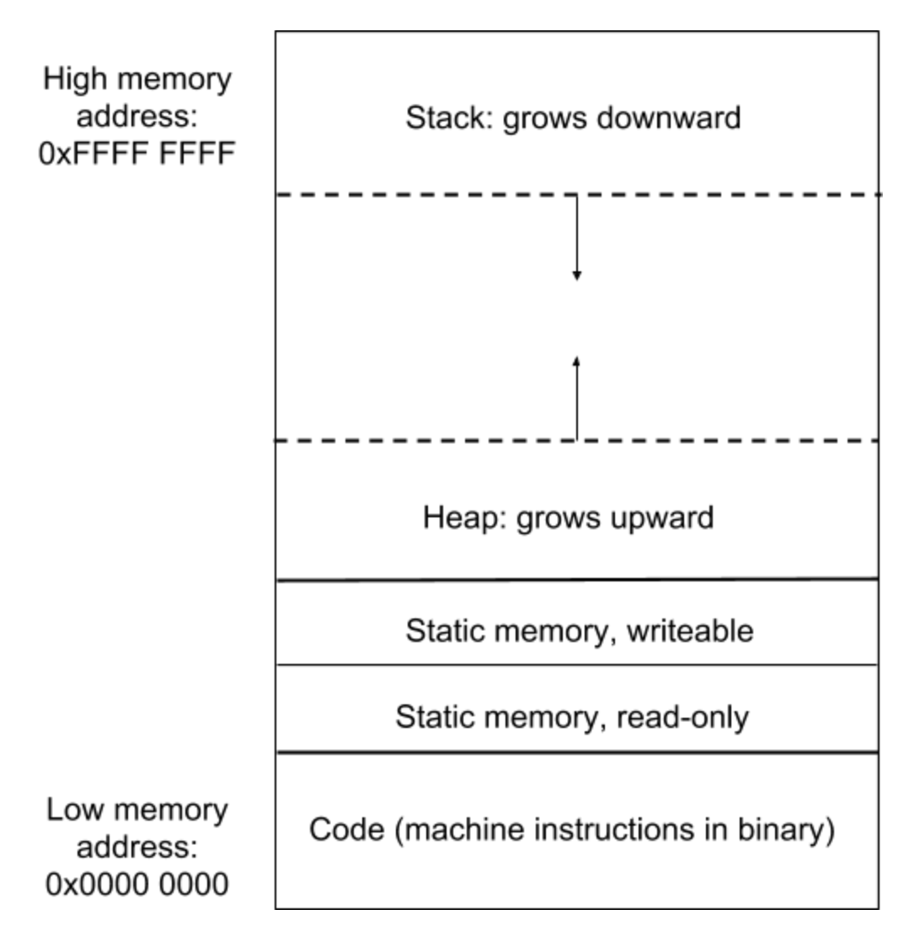

**Heap:** dynamically allocated memory (with malloc, calloc, realloc)

**Static:** global variables, statically allocated strings (e.g. char * = “Go Bears!”, the string literal (“Go Bears!”) is stored in read-only static memory in the compiled executable

**Code:** the 1’s and 0’s that represent the compiled machine instructions for your program

### Dynamic Memory Allocation

* Memory is allocated on the heap with the dynamic memory allocation functions:
  + void* malloc(size_t size)
    - Allocate `size` bytes of space in the heap, return a pointer to it
    - What if we try to allocate more memory than is available in the heap? Returns NULL
  + void* calloc(size_t number_items, size_t size_items)
    - Allocate `size_items` * `number_items` bytes of space in the heap, initialize it to zeroes, return a pointer to it
  + void* realloc(void* ptr, size_t bytes)
    - Move data stored in `ptr` to new space of size `bytes`
    - What if the new “bytes” argument is more than originally allocated? Have garbage at end
    - What if the new “bytes” argument is less than originally allocated? Lose some data
  + void free(void* ptr)
    - De-allocate memory pointed to by `ptr`
    - What happens if we try to free a pointer that’s already free? Double free()s cause heap corruption

CHANGELOG:

-- argv table on page 1 updated!

-- Fixed typo in function signature for free()